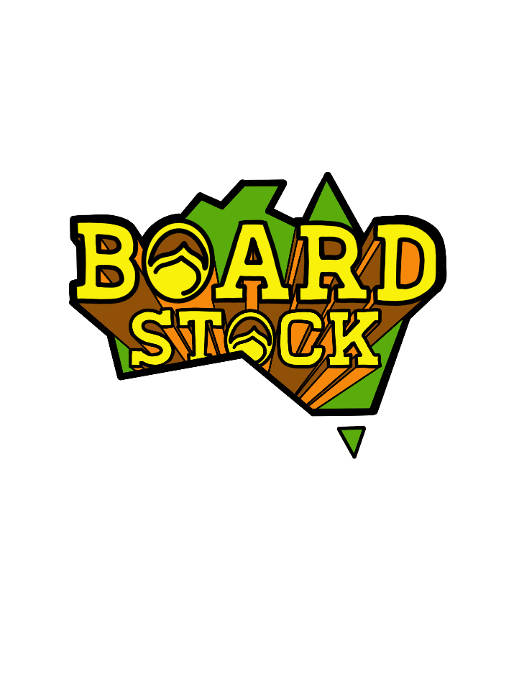

JUDGING Guidelines

The following document has been developed to give riders a basic overview of the judging guidelines -of what the judges are looking for and awarding in all events – King of Kicker, Rail Jam and Traditional. It should be noted these guidelines are only written specifically for the Boardstock Series and in no way relate to any other events that may be run in this country or overseas.

It should also be noted these are very general guidelines and we accept there will always be an exception to every rule. They do however strive to give riders an idea of how the judges will score and an idea of what to expect at the Boardstock Series events

Wakeboarding by nature has a degree of personal interpretation and style and we as a series respect that and have designed our judging structure with that understanding in mind

The Starting Point

The Boardstock Series is a contest. It is a test of wakeboarding skill under contest conditions.
As such the underlying principle is that riders be awarded for whoever can perform the most difficult manoeuvres under the pressure conditions. It should be noted degree of difficulty does not mean the hardest trick – degree of difficulty may be affected by many other factors including the size and intensity of the trick, by the type of grab you apply, by the axis of the spin or the individual variations you may bring to that trick.

KING of KICKER

In judging the KING of KICKER contest the judges are instructed to look at 5 different areas
- What is the trick. And how hard is that trick?
- How well was the trick performed. Riders will be awarded more points for landing the trick cleanly, for executing it well and maintaining good form. Judges will deduct points for poor landings, butt checking, for poor form, zeaching or for pre-spinning
- How big was the trick performed. Intensity and size of the trick will have a huge effect on the degree of difficulty so going larger will be awarded more points than the same trick performed smaller.
- What Grab did they do. Grabbing the board during a trick will be awarded more points than not grabbing the same trick. Judges will also consider what grab it was, the difficulty of that grab and how well that grab was executed. Do not “zeach” the grab
- Individual Flavour and Originality. Respecting the individual and personal nature of the sport judges are always looking for anything “new” a rider may bring to that trick, any original way they may do it or approach it, and will award additional points for that.

Very importantly it needs to be understood that the hardest trick does not always win. A 900 does not always beat a 540. Although the difficulty of the trick is indeed important it is certainly possible for a very large well executed 540 degree spin to beat a poorly executed 1080 spin. The degree of difficulty of the trick is effected by the intensity, by the grab, by the execution and by the individual flavour added, not just how hard the trick is initially

In respecting the personal nature and opinion of the riders in the sport the 3 judges of the King of Kicker will sit separately to each other and will not discuss the tricks. Each judge will rank riders from 1st to last individually, in their own personal opinion using the above guidelines. The 3 judges placings will be added together. Lowest score wins…

RAIL JAM – Obstacles ONLY

Rail Jam is an Obstacles Only event. The following guidelines are designed to give the riders a very broad and
general understanding of a scale of difficulty of manoeuvres on rails and a general directive on what is consider difficult and correct in rail riding. These guidelines have been written to apply to all divisions and levels of riding, although how stringently they are applied will increase as the riding skill level increases.

A “Full Pull” on the Rail – In contest rail riding it is VERY important to ride the full length of the rail from start to finish. Significant points are deducted for not making it to the end of the rail and falling off early.
Showing Control – In contest rail riding it is VERY important to always be in full control on the rail. It should the aim on every rail to be in complete control from end to end. Judges will deduct points for lack of control or poor form
Toe Side versus Heel side – When going onto a rail there is no preference given to whether it is toeside or heelside as relates to degree of difficulty. Neither one is considered harder than the other. Neither are awarded more points than the other.
Regular or Switch – In Rail Jam contest judging (where one judge is judging one obstacle), there is no consideration given to whether the trick is performed regular or switch. This is because the judges do not know the natural stance of every rider that they are judging (Please note this does not apply to line judging in the Pro Division)
Forward versus backwards When riding a rail, right from the beginner level, it is considered more difficult to ride the rail backwards than to ride the rail forwards. More points will be awarded accordingly
Ollie versus Ride on – It is considered more difficult and better technically to “ollie” onto a rail than to ride up the upramp. Ollieing on will be awarded more points
Pressing. Nose versus Tail – It is considered more difficult to nose press than to tail press. Of course each must also be executed correctly and the degree of press will also be taken into account but if performed equally well then the nose press will rate above the tail press
Approaching the Rail versus exiting the Rail. – The difficulty of the tricks performed going ONTO the rail is more important and rated higher than the tricks performed going OFF the rail (at the end). A 360 onto a rail will be awarded higher scores than a 360 off the rail.
ONTO the Rail – The trick you perform and the way you go onto the rail will be a large factor in how that rail scores. When performing any trick onto a rail (whether 90, 180 or 360) you are awarded more points if the tail of the board passes over the rail first than if the nose of the board passes over the rail first. This generally applies to all tricks onto rails whether toeside or heelside.
Transfering – Although a slight preference may be given to a toeside transfer above a heelside transfer the same principle is generally applied as going ONTO a rail. When transferring if the tail passes over the rail first it is generally considered harder than if the nose passes over the rail first. This will apply to all transfers whether 90, 180, 360, 540 and whether toeside or heelside.
Spinning on Rails – Is an acceptable trick in the lower beginning divisions and an acknowledged step in the learning process, but becomes less acceptable as the skill level increases , and will be penalised in higher divisions and pro levels.

Zeaching and Control – being in control and “locking” into that position for the entire rail length is awarded the highest points. If you are sliding with your board across the rail then it should be at 90 degrees to the rail – not 85 or 80 degrees but 90. And that 90 needs to be held exactly at 90 from the start of the rail until the end. Any degrees off 90 or sliding from 90 to any other angle during the rail (referred to as a zeach) will be awarded less points. If sliding 50/50 your board must be in a direct line with the rail – EXACTLY in line is the objective. Slightly off straight or changing from straight to slightly offline during the rail (zeaching) will be scored lower

Very importantly it needs to be understood that the hardest move performed on a rail does not always win. Above all judges are looking for a “locked in” full pull on the rail and are particularly strict on this as the skill level increases. An easier rail move with excellent control and full pull may certainly beat a harder move poorly executed where you fell off the rail before the end.
Of course the aim of every rider is to complete the hardest trick possible whilst maintaining locked in control

Kickers – in a Rail Jam event usually account for about 20% of the score and are judged using the same guidelines as King of Kicker – difficulty, execution, intensity, grabs and variation are all awarded

Body dragging during a Rail Jam event will be cause for disqualification from the event

Judges will rank riders 1st to last on their individual obstacle (or group). Judges score are added together. Lowest score wins

LINE Judging in the PRO Divisions (Rail Jam) only

Central to the Boardstock Judging at the Pro Level is the importance of “Lines”, this is where multiple obstacles are linked together as a line and judged as one unit. The rider must hit each obstacle in the line and will be awarded one score based upon everything he/she did on that line. The obstacles may be on either side of the cable or on the one side of the cable. In most Boardstock events there will be 2 lines to hit, one on the front straight and one on the back straight, and in general will be weighted as the 2 most important scores in the layout.
Spinning Both Ways – This is a priority when judging lines and is the main reason that we have them. Riders are awarded higher points for showing that they can perform tricks in both directions. Spinning in the same direction (even if two different tricks) will be scored lower.
Switch and Regular – Hitting obstacles in the line both switch and regular stance will also be rewarded. (A soccer player who can only kick with one foot is only half a player)
Flow and Variety – The tricks performed on each rail should flow together and display a variety of moves and techniques

Please note LINES are only used in the Pro Mens and Womens events so these comments only apply to these divisions

.

TRADITIONAL

The Boardstock Series events will feature on Open Pro Division of Traditional Cable. Any riders, male or female, of any age may enter.
The course will be one lap starting directly off the dock and riders will be scored for everything performed on that lap. Obstacles, Kickers and Water tricks can be performed on any area of the course. There will be no pickups. Once a rider falls that run is complete. Each rider will receive two turns at the course. Only the best score will count.

Body dragging during a Traditional Event will cause that run to be scored as a ZERO

A panel of 3 judges will record every trick performed during that lap and award 1 score for the entire lap. The same principles outlined in the Rail Jam and King of kicker events will still apply to the obstacles and kickers. Judges will also list water tricks performed scoring them on difficulty, intensity, execution, variety and composition (meaning toeside/heelside and switch/regular as well as flow). There is no percentages or separate categories in the Boardstock Traditional Judging but rather the entire run is considered as one whole unit and scored accordingly

Judges will sit together and may discuss tricks performed during the runs but will still score the runs individually. Judges are not required to agree and may certainly disagree in their final individual scores/rankings. Each individual judge will rank riders 1st to last, using the riders single best run only, and submit their sheets to the scorers. Scorers will add these together. Lowest score wins.

